Sr.No | Project Defination
1. | Write a program to print "Welcome to JavaScript" using console.log().
Code | <html>  <head>  <title>Practical-1</title>  </head>  <body>  <script>console.log("Welcome To Javascript");</script>  </body>  </html>
Output | 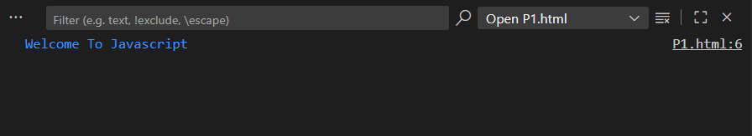
2. | Write a JavaScript program to display student details (Name, Age, and Course) on a web page using document.write().
Code | <html>  <head>  <title>Practical-2</title>  </head>  <body>  <script>  document.write("Name: Darshil Patel");  document.write("<br> Age: 24" );  document.write("<br> Course: MSC-IT" );  </script>  </body>  </html>
Output | 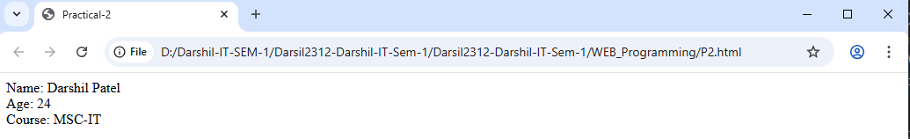
3. | Write a JavaScript code to display the message “Hello ISTAR!”. (Alert Dialog Box)
Code | <html>  <head>  <title>Practical-3</title>  </head>  <body>  <script>  alert("Hello ISTAR!");  </script>  </body>  </html>
Output | 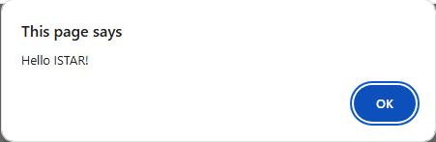
4. | Ask the user for their name using prompt() and display it back with alert().
Code | <html>  <head>  <title>Practical-4</title>  </head>  <body>  <script>  user = prompt("Enter Your Name:");  alert("Hello! " + user);  </script>  </body>  </html>
Output | 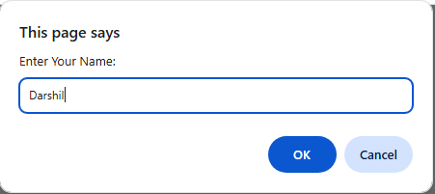  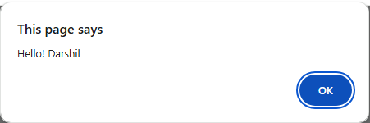
5. | Use let and const to declare variables, and try re-assigning them (observe difference).
Code | <html>  <head>  <title>Practical-5</title>  </head>  <body>  <script>  let x = prompt("Enter Initial Value Of X:");  console.log("Initial Value Of x:", x);  x = prompt("Enter Reassigned Value Of X:");  console.log("Reasigned Value Of x: ", x);  const y = prompt("Enter Initial Value Y:");  console.log("Initial Value Of y:", y);  y = prompt("Enter Reassigned Value Of Y:")  console.log("reassigned value of y:", y);  </script>  </body>  </html>
Output | 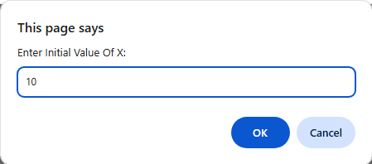  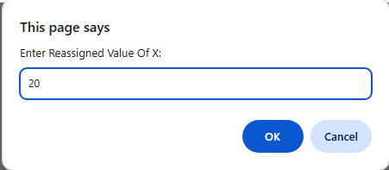  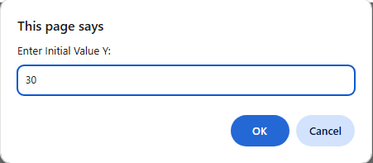  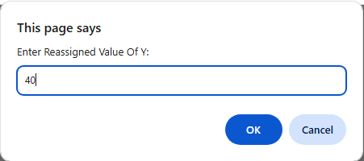  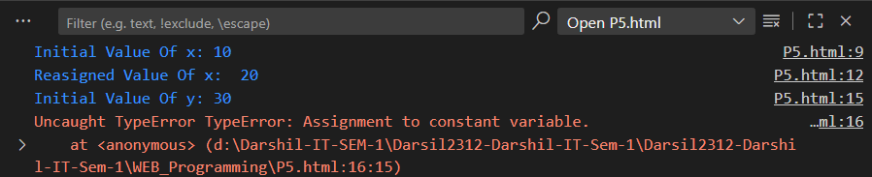
6. | Write a program to find typeof all variable of JavaScript .
Code | <html>  <head>  <title>Practical-6</title>  </head>  <body>  <script>  let x = "Darshil Patel";  let y = 24;  let z = false;  let p = [15, 21, 33];  let q = { name: "DDP" };  let r = null;  let s;  console.log(typeof x);  console.log(typeof y);  console.log(typeof z);  console.log(typeof p);  console.log(typeof q);  console.log(typeof r);  console.log(typeof s);  </script>  </body>  </html>
Output | 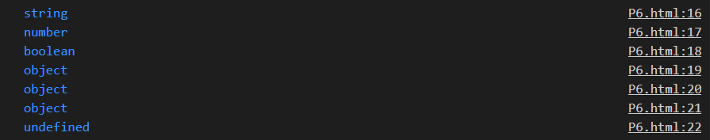
7. | Write a program to add, subtract, division, and multiplication of given numbers.
Code | <html>  <head>  <title>Practical-7</title>  </head>  <body>  <script>  let n1 = parseInt(prompt("Enter Number 1:"));  let n2 = parseInt(prompt("Enter Number 2:"));  let add = n1 + n2;  let sub = n1 - n2;  let mul = n1 * n2;  let div = n1 / n2;  document.write("Addition: " + add);  document.write("Subtraction: " + sub);  document.write("Multiplication: " + mul);  document.write("Division: " + div);  </script>  </body>  </html>
Output | 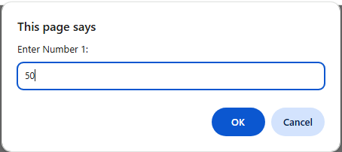  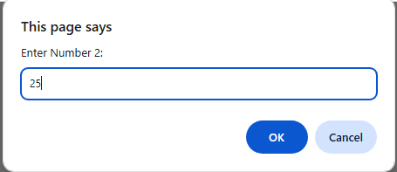  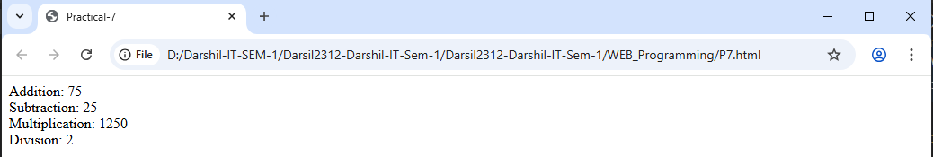
8. | Write a program to convert Fahrenheit to Celsius.
Code | <html>  <head>  <title>Practical-8</title>  </head>  <body>  <script>  let fah = prompt("Enter Fah:");  let cel = (fah - 32) * 5 / 9;  document.write(fah + " F is equal to " + cel.toFixed(2) + " C ");  </script>  </body>  </html>
Output | 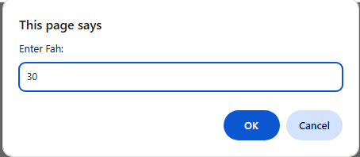  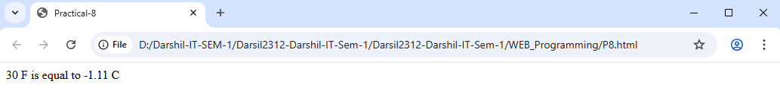
9. | Write a program to convert Celsius to Fahrenheit.
Code | <html>  <head>  <title>Practical-9</title>  </head>  <body>  <script>  let cel = prompt("Enter Cel:");  let fah = (cel * 9 / 5) + 32;  document.write(cel + " C is equal to " + fah.toFixed(2) + " F ");  </script>  </body>  </html>
Output | 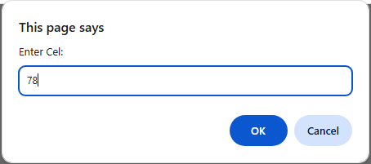  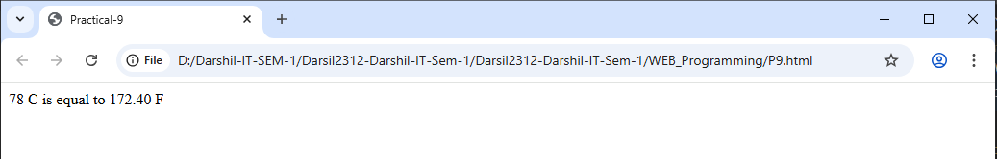
10. | WRITE a program to find answer of ax2 +b*x + c.
Code | <html>  <head>  <title>Practical-10</title>  </head>  <body>  <script>  let a = prompt("Enter Value Of a:");  let b = prompt("Enter Value Of b:");  let c = prompt("Enter Value Of c:");  let x = prompt("Enter Value Of d:");  let result = a * x * x + b * x + c;  document.write("The value of ax² + bx + c is: " + result);  </script>  </body>  </html>
Output | 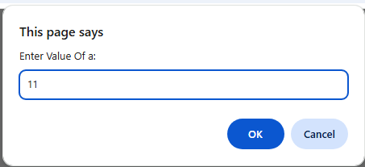  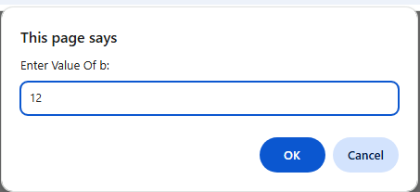  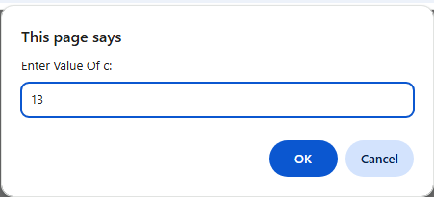  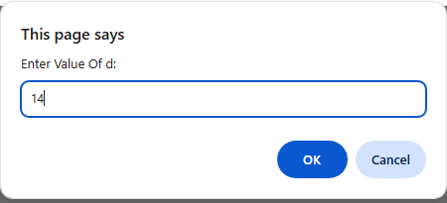  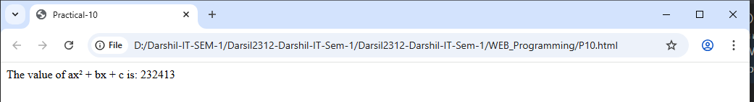
11. | Write a program to find large number among two numbers.
Code | <html>  <head>  <title>Practical-11</title>  </head>  <body>  <script>  let n1 = parseInt(prompt("Emter Number 1:"));  let n2 = parseInt(prompt("Enter Number 2:"));  if (n1 > n2)  {  document.write("The larger number is: " + n1);  }  else if (n2 > n1)  {  document.write("The larger number is: " + n2);  }  else  {  document.write("Both numbers are equal.");  }  </script>  </body>  </html>
Output | 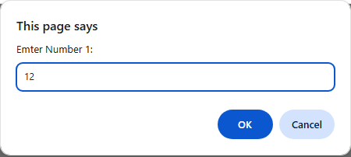  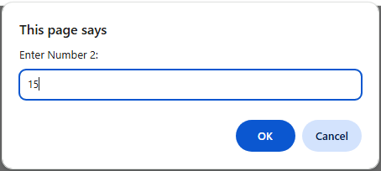  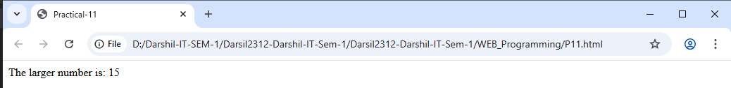
12. | Write a program to find large number among given three numbers.
Code | <html>  <head>  <title>Practical-12</title>  </head>  <body>  <script>  let n1 = prompt("Enter Value Of Number 1:");  let n2 = prompt("Enter Value Of Number 2:");  let n3 = prompt("Enter Value Of Number 3:");  let largest;  if (n1 >= n2 && n1 >= n3)  {  largest = n1;  }  else if (n2 >= n1 && n2 >= n3)  {  largest = n2;  }  else  {  largest = n3;  }  document.write("The largest number is: " + largest);  </script>  </body>  </html>
Output | 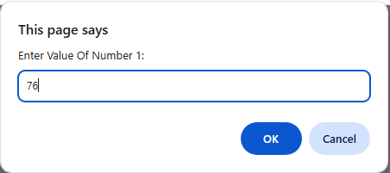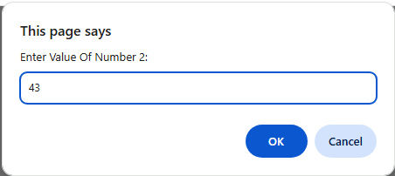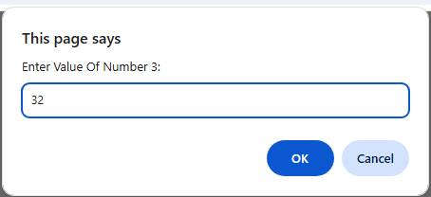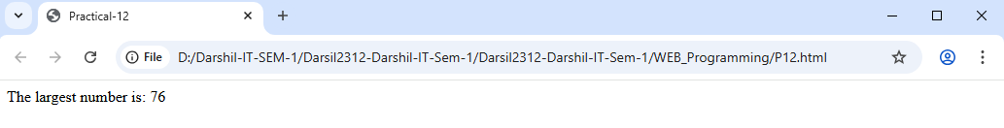
13. | Write a program to check whether the number is positive, negative or zero.
Code | <html>  <head>  <title>Practical-13</title>  </head>  <body>  <script>  let n = parseFloat(prompt("Enter a number:"));  if (n > 0)  {  alert("The " + n + " is positive.");  }  else if (n < 0)  {  alert("The " + n + " is negative.");  }  else  {  alert("The " + n + " is zero.");  }  </script>  </body>  </html>
Output | 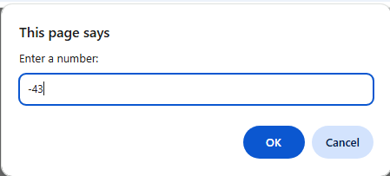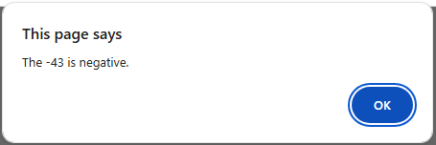
14. | Write a JavaScript code to display the message as "Are you sure you want to proceed?" and display the message as "Completed successfully." If press OK button, then display the message as "You have cancelled it." If press Confirm button. (Confirm dialog box)
Code | <html>  <head>  <title>Practical-14</title>  </head>  <body>  <script>  let userresponse = confirm("Are you sure you want to proceed?");  if (userresponse)  {  alert("Completed successfully.");  }  else  {  alert("You have cancelled it.");  }  </script>  </body>  </html>
Output | 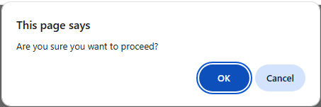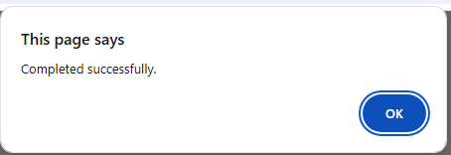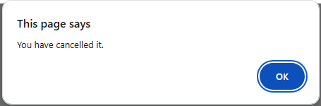
15. | Get one number as “age” from user and check whether he/she is eligible for voting or not. (Prompt dialog box)
Code | <html>  <head>  <title>Practical-15</title>  </head>  <body>  <script>  let age = parseInt(prompt("Enter your age:"));  if (age >= 18)  {  alert("You are eligible to vote.");  }  else  {  alert("You are not eligible to vote.");  }  </script>  </body>  </html>
Output | 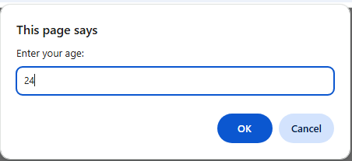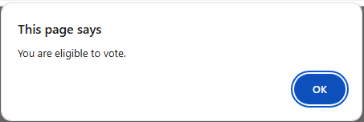
16. | Write a function greet() that prints "Hello, Welcome to JavaScript!".
Code | <html>  <head>  <title>Practical-16</title>  </head>  <body>  <script>  function greet()  {  document.write("Hello, Welcome to JavaScript!");  }  greet();  </script>  </body>  </html>
Output | 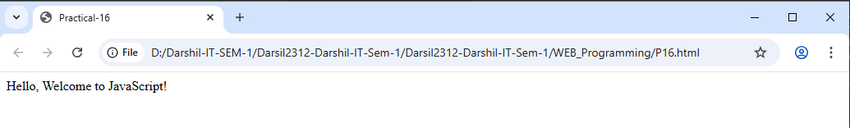
17. | Write a function square(num) that returns the square of a number.
Code | <html>  <head>  <title>  </title>  </head>  <body>  <script>  function square(num)  {  return num * num;  }  let n = parseInt(prompt("Enter a number to square:"));  let result = square(n);  document.write("The square of ", n , " is ", result);  </script>  </body>  </html>
Output | 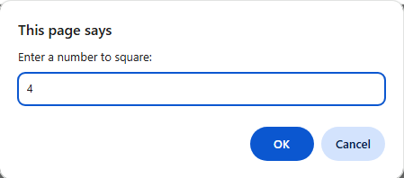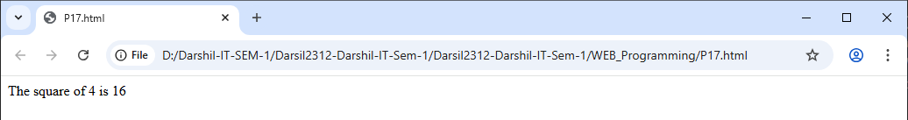
18. | Write a function isEven(num) that checks whether a number is even or odd.
Code | <!DOCTYPE html>  <html>  <head>  <title>Practical-18</title>  </head>  <body>  <script>  let n = parseInt(prompt("Enter a number:"));  function isEven(num) {  return num % 2 === 0;  }  if (isEven(n))  {  document.write(n + " is even.</h2>");  }  else  {  document.write(n + " is odd.</h2>");  }  </script>  </body>  </html>
Output | 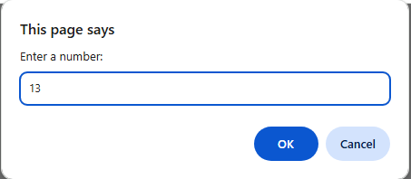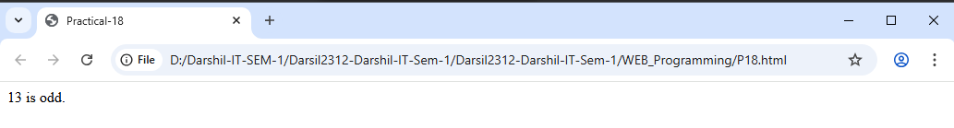
19. | Write a function add(a, b) that takes two numbers and returns their sum.
Code | <!DOCTYPE html>  <html>  <head>  <title>Practical-19</title>  </head>  <body>  <script>  function add(a,b)  {  return a+b;  }  n1=parseInt(prompt("Enter A Value Of a: "));  n2=parseInt(prompt("Enter A Value Of b:"));  result=add(n1,n2);  document.write("The Sum Of " + n1 + " and " + n2 + " Is " + result);  </script>  </body>  </html>
Output | 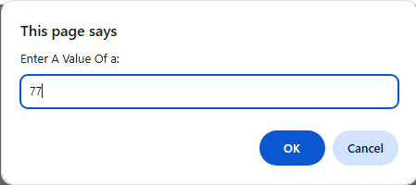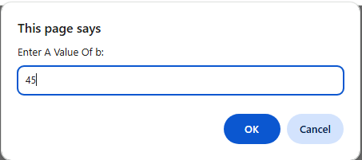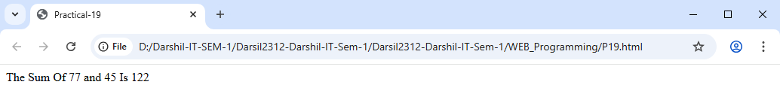
20. | Write a function findMax(a, b) that returns the larger of two numbers.
Code | <!DOCTYPE html>  <html>  <head>  <title>Practical-20</title>  </head>  <body>  <script>  function FindMax(a,b)  {  if(a>b)  {  return a  }  else  {  return b  }  }  n1=parseInt(prompt("Enter A Value Of Number 1: "));  n2=parseInt(prompt("Enter A Value Of Number 2: "));  result=FindMax(n1,n2);  document.write("The Larger Number Is: " + result);  </script>  </body>  </html>
Output | 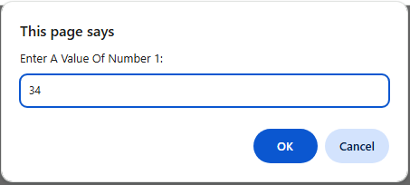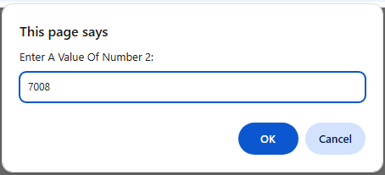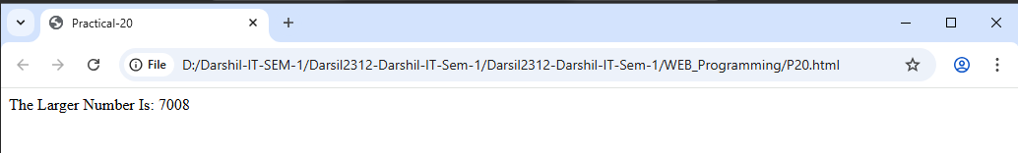
21. | Write a function sumArray(arr) that returns the sum of all elements in an array.
Code | <html>  <head>  <title>Practical-21</title>  </head>  <body>  <script>  let arr = [23,32,12,43,34];  function sumArry()  {  let sum=0;  for(let i=0;i<arr.length;i++)  {  sum = sum + arr[i];  }  return sum;  }  result=sumArry(arr);  document.write("Sum Of Arry Elements: " + result);  </script>  </body>  </html>
Output | 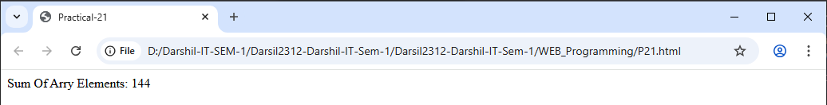
22. | Write a function findLargest(arr) that finds the largest element in an array.
Code | <html>  <head>  <title>Practical-22</title>  </head>  <body>  <script>  let arr = [23,32,12,43,34];  function findLargest(arr)  {  let largest = arr[0];  for (let i = 1; i < arr.length; i++)  {  if (arr[i] > largest)  {  largest = arr[i];  }  }  return largest;  }  result=findLargest(arr);  document.write("Largest Arry Element: " + result);  </script>  </body>  </html>
Output | 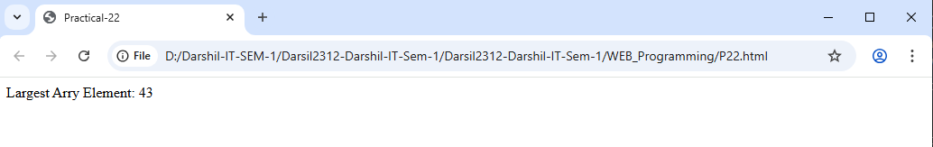
23. | Write a function countEvenNumbers(arr) that counts how many even numbers are in an array.
Code | <html>  <head>  <title>Practical-23</title>  </head>  <body>  <script>  let arr = [23, 32, 12, 43, 34];  function countEvenNumbers(arr)  {  let count = 0;  for (let i = 0; i < arr.length; i++) {  if (arr[i] % 2 === 0) {  count++;  }  }  return count;  }  let evenCount = countEvenNumbers(arr);  document.write("Count of Even Numbers: " + evenCount);  </script>  </body>  </html>
Output | 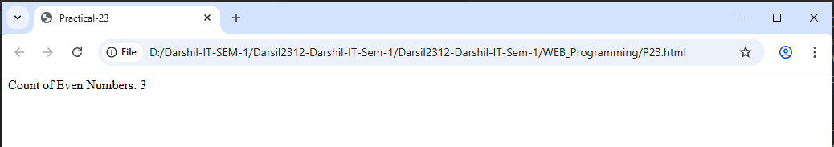
24. | Write a function filterOddNumbers(arr) that returns only odd numbers from an array.
Code | <html>  <head>  <title>Practical-24</title>  </head>  <body>  <script>  let arr = [23, 32, 12, 43, 34];  function filterOddNumbers(arr)  {  let oddNumbers = [];  for (let i = 0; i < arr.length; i++) {  if (arr[i] % 2 !== 0)  {  oddNumbers.push(arr[i]);  }  }  return oddNumbers;  }  let result = filterOddNumbers(arr);  document.write("Odd numbers: ", result);  </script>  </body>  </html>
Output | 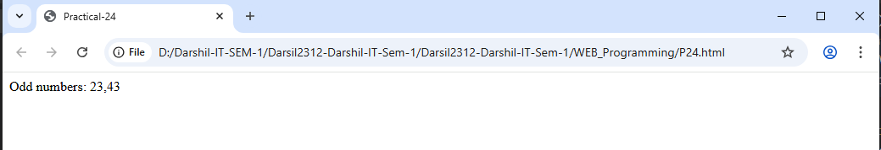
25. | Write a function average(arr) that finds the average of an array of numbers.
Code | <html>  <head>  <title>Practical-25</title>  </head>  <body>  <script>  let arr = [23,32,12,43,34];  function average()  {  let sum=0;  for(let i=0;i<arr.length;i++)  {  sum = sum + arr[i];  }  return sum/arr.length;  }  result=average(arr);  document.write("Average Of Array Elements: " + result);  </script>  </body>  </html>
Output | 